Losses and EFFICIENCY OF TRANSFORMER

Losses in Transformer
In any electrical machine, 'loss' can be defined as the difference between input power and output power. An electrical transformer is a static device, hence mechanical losses (like windage or friction losses) are absent in it. A transformer only consists of electrical losses (iron losses and copper losses). Transformer losses are similar to losses in a DC machine, except that transformers do not have mechanical losses.
Losses in transformer are explained below –

Core Losses Or Iron Losses
Eddy current loss and hysteresis loss depend upon the magnetic properties of the material used for the construction of core. Hence these losses are also known as core losses or iron losses.
Hysteresis loss in transformer: Hysteresis loss is due to reversal of magnetization in the transformer core. This loss depends upon the volume and grade of the iron, frequency of magnetic reversals and value of flux density.
It can be given by, Steinmetz formula: W_{h}= ηB_{max}^{1.6}fV watts
Where, η = Steinmetz hysteresis constant
V = volume of the core in m³
Eddy current loss in transformer: In transformer, AC current is supplied to the primary winding which sets up alternating magnetizing flux. When this flux links with secondary winding, it produces induced emf in it. But some part of this flux also gets linked with other conducting parts like steel core or iron body or the transformer, which will result in induced emf in those parts, causing small circulating current in them. This current is called as eddy current. Due to these eddy currents, some energy will be dissipated in the form of heat.
It can be given by: W_{e}= K_{e}B_{max}²f²t²V watts
Where, t: Thickness of the laminations

Copper Loss in Transformer
Copper loss is due to resistance of the transformer windings. Copper loss for the primary winding is I₁²R₁ and for secondary winding is I₂²R₂. Where, I₁ and I₂ are current in primary and secondary winding respectively, R₁ and R₂ are the resistances of primary and secondary winding respectively. It is clear that Cu loss is proportional to square of the current, and current depends on the load. Hence copper loss in transformer varies with the load.

Efficiency of Transformer
Just like any other electrical machine, efficiency of a transformer can be defined as the output power divided by the input power.
Efficiency = output / input
Transformers are the most highly efficient electrical devices. Most of the transformers have full load efficiency is in between 95% to 98.5%. As a transformer being highly efficient, output and input are having nearly same value.

The efficiency is defined as follows:

$$η=\frac{\text{output} \text{power} \left(P_{\text{out}}\right)}{\text{Input} \text{Power}\left(P_{\text{in}}\right)}∗\text{100}=\frac{P_{\text{out}}}{P_{\text{out}}+\text{Losses}}∗\text{100}$$
The losses in the transformer are the core loss $\left(P_{c}\right)$ and copper loss $\left(P_{\text{cu}}\right)$. Therefore,
$$η=\frac{P_{\text{out}}}{P_{\text{out}}+\text{Losses}}=\frac{P_{\text{out}}}{P_{\text{out}}+P_{c}+P_{\text{cu}}}$$
The copper loss can be determined if the winding currents and their resistances are known:
$$\begin{aligned}P_{\text{cu}}=I_{1}^{2}R_{1}+I_{2}^{2}R_{2} \\ = I_{1}^{2}R_{\text{eq}1}=I_{2}^{2}R_{\text{eq}2}\end{aligned}$$
$$P_{\text{out}}=V_{2}I_{2}\text{cos}ϕ_{2}$$
Therefore,
$η=\frac{V_{2}I_{2}\text{cos}ϕ_{2}}{V_{2}I_{2}\text{cos}ϕ_{2}+P_{c}+I_{2}^{2} R_{\text{eq}2}}$* 100
$$η=\frac{V_{2}^{'}∗I_{2}^{'} \text{*cos} ϕ_{2}}{V_{2}^{'}∗I_{2}^{'} \text{*cos} ϕ_{2}+P_{c}+I_{2}^{}R_{\text{eq}1}}∗\text{100}$$

Maximum Efficiency
For constant values of the terminal voltage $V_{2}$and load power factor angle$ϕ_{2}$, the maximum efficiency occurs when:
$$\frac{dη}{{\text{dI}}_{2}}=0$$
Therefore the condition for maximum efficiency is:
$$P_{c}=I_{2}^{2}R_{\text{eq}2}$$
That is, core loss = copper loss.
For full load condition,
$$P_{\text{cu},\text{FL}}=I_{2,\text{FL}}^{2}R_{\text{eq}2}$$
Let
$$x=\frac{I_{2}}{I_{2,\text{FL}}}=\text{per} \text{unit} \text{loading}$$
$P_{c}=x^{2}P_{\text{cu},\text{FL}}$

TESTING OF SINGLE PHASE TRANSFORMER

All the transformers are tested before placing them in the field. By performing these tests, we can determine the parameters of a transformer to compute its performance characteristics (like voltage regulation and efficiency.).
To furnish the required information, open circuit and short circuit tests are conducted conveniently without actually loading the transformer.
Open-circuit or No-load Test
This test is carried out to determine the no-load loss or core loss or iron loss and no-load current I₀which is helpful in finding the no-load parameters, that is, exciting resistance R₀ and X₀ exciting reactance of the transformer.
This test is usually carried out on the low-voltage side of the transformer.
The low voltage winding is connected to the normal rated voltage V₁ as given on the name plate of the transformer. The high voltage winding is kept open as shown in Fig. 2.1. Since the high-voltage winding is open circuit, the current drawn by the primary is called no-load current I₀ measured by the ammeter A. The value of no-load current I₀ is very small usually 2% to 10% of the rated full-load current. Thus, the copper loss in the primary is negligibly small and no copper loss occurs in the secondary as it is open. Therefore, wattmeter reading W₀ only represents the core or iron losses for all practical purposes. These core losses are constant at all loads.
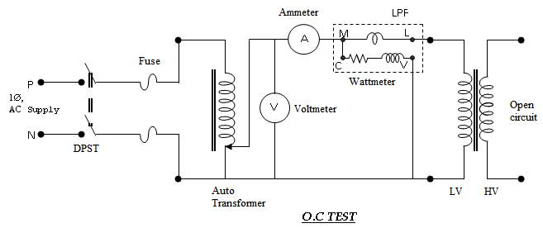
Fig. 2.1 Circuit for open circuit test

Open circuit test
I_{O} = open circuit current, Amperes
V_{O} = open circuit voltage, Volts
W_{O} = open circuit power, Watts
W_{O} = V_{O} * I_{O} * cos∅_{O ,} Watts
where , cos∅_{O} = No load power factor.
∴ cos∅_{O} = W_{O}/(V_{O} * I_{O})
I_{w} = working current = I_{O} * cos ∅_{O}
I_{m} = magnetizing current = I_{O} * sin ∅_{O}
R_{m} = V_{O}/I_{w}
X_{m} = V_{O}/I_{m}
The Iron losses measured by this test are used to determine transformer efficiency and parameters of exciting circuit of a transformer.

Short Circuit Test
This test is carried out to determine the following:
- Copper losses at full load (or at any desired load). These losses are required for the calculations of efficiency of the transformer.
- Equivalent impedance (Z_{es} or Z_{ep}), resistance (R_{es} or R_{ep}) and leakage reactance (X_{es} or X_{ep}) of the transformer referred to the winding in which the measuring instruments are connected. Knowing equivalent resistance and reactance, the voltage drop in the transformer can be calculated and hence regulation of transformer is determined.
This test is usually carried out on the high-voltage side of the transformer.
The High voltage winding is short circuited by a thick strip across the terminals as shown in Fig. 2.1. A low voltage at normal frequency is applied to the high-voltage winding with the help of on autotransformer so that full-load current flows in both the windings, measured by ammeters A. Low voltage is essential, failing which an excessive current will flow in both the windings that may damage them. Since a low voltage (usually 5 to 10% of normal rated voltage) is applied to the transformer winding, therefore, the flux set-up in the core is very small.
The iron losses are negligibly small due to low value of flux as these losses are approximately proportional to the square of the flux. Hence, wattmeter reading W_{c} only represents the copper losses in the transformer windings for all practical purposes. The applied voltage V_{2sc} is measured by the voltmeter V which circulates the current I_{2sc} (usually full-load current) in the impedance Z_{es} of the transformer to the side in which instruments are connected as shown in Figure 10.33.
Let the wattmeter reading = W_{c}
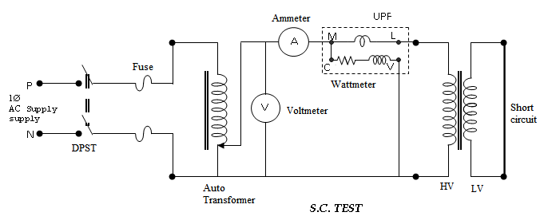
Fig. 2.2 Circuit for short circuit test

Short circuit test

I_{SC} = short circuit current, Amps
V_{SC} = voltage applied in the short circuit test, Volts
W_{SC} = power consumed in short circuit test, Watts
W_{SC} = V_{SC} * I_{SC} * cos∅_{SC,} Watts
∴ cos∅_{SC} = W_{SC}/(V_{SC} * I_{SC})
Z_{O2} = V_{SC} /I_{SC}
R_{O2} = Z_{O2} * cos∅_{SC}
X_{O2} = Z_{O2} * sin∅_{SC}
R_{O1} = R_{O2}/K² ; X_{O1} = X_{O2}/K²
Where, K = transformation ratio= V₂/V₁
After calculating R_{o2} and X₀₂, the voltage regulation of the transformer can be determined at any load and power factor.
Equivalent Circuit of 1ϕ-Transformer
The equivalent circuit of 1ϕ-Transformer is as shown in fig. 2.3.
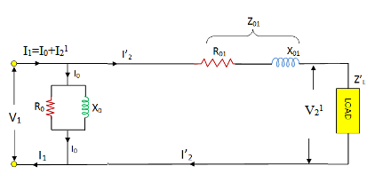
Fig. 2.3. Total equivalent circuit of the transformer referred to primary
Where
V₁ = Primary voltage in volts
V₂¹ = Secondary voltage referred to primary in volts
I₁ = Primary Current in amps
I₂¹ = Secondary current referred to primary in amps
I₀ = No- load current in amps
R₀ = Excitation resistance in ohms
X₀ = Excitation reactance or magnetizing reactance in ohms
R₀₁ = R₁ + R₂¹ = Total equivalent resistance referred to primary in ohms
X₀₁ = X₁ + X₂¹ = Total equivalent reactance referred to primary in ohms
Where
R₁ = Primary winding resistance in ohms
X₁ = Primary winding reactance in ohms
R₂¹ = Secondary winding resistance referred to primary in ohms = R₂/K²
X₂¹ = Secondary winding reactance referred to primary in ohms = X₂/K²
R₂ = Secondary winding resistance in ohms
X₂ = Secondary winding reactance in ohms
K = Transformation ratio = N₂/N₁ = V₂/V₁
Z_{L}¹ = Load impedance referred to primary in ohms

Transformer Voltage Regulation
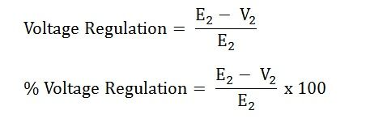
Where,
E₂ – secondary terminal voltage at no load
V₂ – secondary terminal voltage at full load
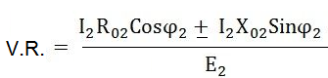

Condition for Zero and Maximum Voltage Regulation
For Zero voltage regulation:
Zero voltage regulation means, Sending end voltage and Receiving end voltage become equal. This case is also known as ideal voltage regulation and is possible with leading power factor loads.
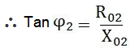
Where Φ₂ is the angle between V₂ & I₂ and Current (I₂) leads the Voltage (V₂).
For maximum voltage regulation:
Maximum voltage regulation is (positive) possible with lagging power factor loads.
For getting maximum V.R
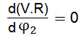
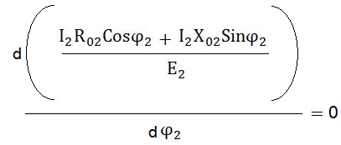
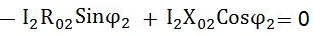
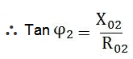

Where Φ₂ is the angle between V₂ & I₂ and Current (I₂) lags the Voltage (V₂).
Graph between the percentage Voltage regulation and power factor as shown in fig. 2.4.
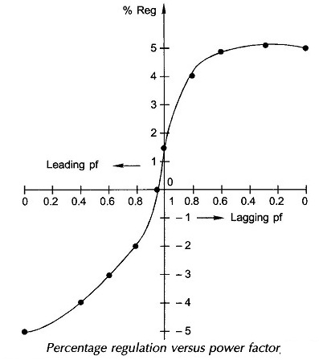
Fig. 2.4

Sumpner's Test Or Back-To-Back Test On Transformer

Sumpner's test or back to back test on transformer is another method for determining transformer efficiency, voltage regulation and heating under loaded conditions. Short circuit and open circuit tests on transformer can give us parameters of equivalent circuit of transformer, but they cannot help us in finding the heating information. Unlike O.C. and S.C. tests, actual loading is simulated in Sumpner's test. Thus the Sumpner's test gives more accurate results of regulation and efficiency than O.C. and S.C.tests.
Sumpner's test or back to back test can be employed only when two identical Transformers are available. Both transformers are connected to supply such that one transformer is loaded on another. Primaries of the two identical transformers are connected in parallel across a supply. Secondaries are connected in series such that emf's of them are opposite to each other. Another low voltage supply is connected in series with Secondaries to get the readings, as shown in the circuit diagram shown in fig. 2.5.
Note: Close SPST if V₃ shows zero otherwise change the polarity of any one of the secondary winding.
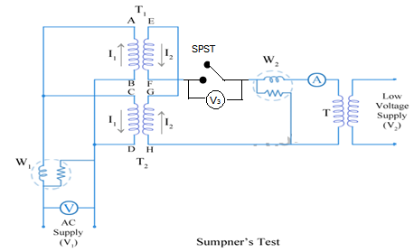

Fig. 2.5
In the above diagram fig. 2.5, T₁ and T₂ are identical transformers. Secondaries of them are connected in voltage opposition, i.e. E_{EF} and E_{GH}. Both the emf's cancel each other, as transformers are identical. In this case, as per superposition theorem, no current flows through secondary. And thus the no load test is simulated. The current drawn from V₁ is 2I₀, where I₀ is equal to no load current of each transformer. Thus input power measured by wattmeter W₁ is equal to iron losses of both transformers.
i.e. iron loss per transformer Pi = W₁/2.

Now, a small voltage V₂ is injected into secondary with the help of a low voltage transformer. The voltage V₂ is adjusted so that, the rated current I₂ flows through the secondary. In this case, both primaries and secondaries carry rated current. Thus short circuit test is simulated and wattmeter W₂ shows total full load copper losses of both transformers.
i.e. copper loss per transformer P_{Cu} = W₂/2.
From above test results, the full load efficiency of each transformer can be given as –

% full load efficiency of each transformer = $\frac{\text{output}}{\text{output}+\frac{W_{1}}{2}+\frac{W_{2}}{2}}∗\text{100}$
Advantages of the test:
- The power required to carry out the test is small.
- The transformers are tested at full-load conditions.
- As the test results gives the value of core and copper losses occurring simultaneously so heat run test can be conducted on two transformers.
- The secondary current (i.e I₂) can be varied to any value using regulating transformer. Hence we can determine the copper losses at full load condition or at any load.

Drawbacks of the test:
Only limitation is that two identical transformers are required. In practice exact identical transformers cannot be obtained and as two transformers are required, the test is not economical.

Separation of Core (or Iron) Losses In A Transformer
Hysteresis loss and eddy current loss are the components of the iron losses.
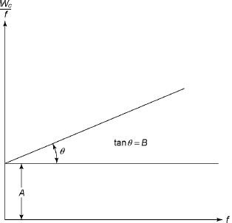
Hysteresis loss in transformer is denoted as,
W_{h}= K_{h} B_{m}^{1.6} f watts,
Eddy current loss in transformer is denoted as,
W_{e}= K_{e} K_{f}B_{m}² f² watts
For the applied flux density B_{max} constant to the core, we have
Hysteresis loss = Af
and Eddy current loss = Bf²
The no load loss can be expressed as
W_{C}= Af+Bf²
Where A and B are constants.

Therefore, Fig. 2.6
Fig. 2.6 shows the graph, which is a straight line when W_{C}/f and f are plotted along the y-axis and x-axis, respectively. The intercept on the y-axis gives the value of A, whereas the slope of the line gives the value of B. Now the hysteresis and eddy current loss can be determined at any desired frequency.

Parallel operation of transformers

Reasons
- To maximize electrical power system availability: If numbers of transformers run in parallel, we can shutdown any one of them for maintenance purpose. Other parallel transformers in system will serve the load without total interruption of power.
- To maximize power system reliability: if any one of the transformers run in parallel, is tripped due to fault of other parallel transformers is the system will share the load, hence power supply may not be interrupted if the shared loads do not make other transformers over loaded.
- To maximize electrical power system flexibility: There is always a chance of increasing or decreasing future demand of power system. If it is predicted that power demand will be increased in future, there must be a provision of connecting transformers in system in parallel to fulfill the extra demand. Again if future demand is decreased, transformers running in parallel can be removed from system to balance the capital investment and its return.

Conditions for Parallel Operation of Transformers
When two or more transformers run in parallel, they must satisfy the following conditions for satisfactory performance.
Same Voltage Ratio
If two transformers of different voltage ratio are connected in parallel with same primary supply voltage, there will be a difference in secondary voltages. Now say the secondary of these transformers are connected to same bus, there will be a circulating current between Secondaries and therefore between primaries also. As the internal impedance of transformer is small, a small voltage difference may cause sufficiently high circulating current causing unnecessary extra I²R loss.

Same Percentage Impedance
The current shared by two transformers running in parallel should be proportional to their MVA ratings. Again, current carried by these transformers are inversely proportional to their internal impedance. From these two statements it can be said that, impedance of transformers running in parallel are inversely proportional to their MVA ratings. In other words, percentage impedance or per unit values of impedance should be identical for all the transformers that run in parallel.

Same Polarity
Polarity of all transformers that run in parallel should be the same otherwise huge circulating current that flows in the transformer but no load will be fed from these transformers.

Same Phase Sequence
The phase sequence or the order, in which the phases reach their maximum positive voltage, must be identical for two parallel transformers. Otherwise, during the cycle, each pair of phases will be short circuited.

Parallel Operation of a Single Phase Transformer
. The circuit diagram of two single phase transformer A and B connected in parallel are shown in fig. 2.7.
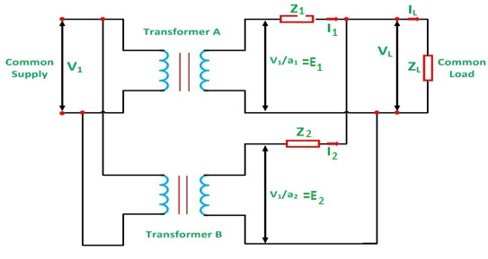
Fig. 2.7
Let,
a₁ is the turn ratio of the transformer 1
a₂ is the turn ratio of the transformer 2
Z₁ is the equivalent impedance of the transformer 1 referred to secondary
Z₂ is the equivalent impedance of the transformer 2 referred to secondary
Z_{L} is the load impedance across the secondary
I₁ is the current supplied to the load by the secondary of the transformer 1
I₂ is the current supplied to the load by the secondary of the transformer 2
V_{L} is the secondary load voltage
I_{L} is the load current

Parallel Operation of Transformers with Equal Voltage Ratios
Let us now consider the case of two transformers connected in parallel having equal voltage ratios. The two transformers are having no load secondary voltage same. i.e. E₁ = E₂ = E. These voltages are in phase with each other. This is possible if the magnetizing currents of the two transformers are not much different. With this case the primaries and secondaries of the two transformers can be connected in parallel and no current will circulate under no load condition. This is represented in the Fig. 2.8.
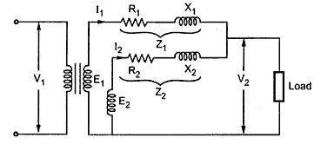
Fig. 2.8
If we neglect magnetizing components, the two transformers are represented as shown in the Fig. 2.9.
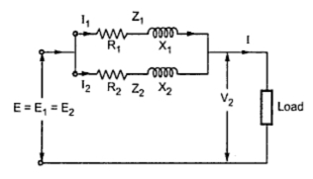
Fig. 2.9
The phasor diagram under this case is shown in the Fig. 2.10. The two impedances Z₁ and Z₂ are in parallel. The values of Z₁ and Z₂ are with respect to secondary.
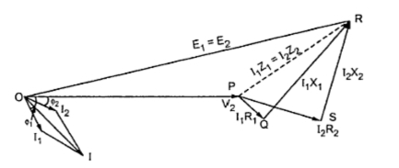
Fig. 2.10
Z₁ and Z₂ are in parallel therefore the equivalent impedance is given by,
1/Z_{eq} = 1/Z₁ + 1/Z₂ Z_{eq} = Z₁ Z₂ / (Z₁ + Z₂₎
As seen from the phasor diagram
I₁ Z₁ = I₂ Z₂ = I Z_{eq}
I₁ = I Z_{eq}/ Z₁ = I Z₂ / (Z₁ + Z₂₎
I₂ = I Z_{eq}/ = I Z₁/ (Z₁ + Z₂₎
Multiplying both terms of above equation by voltage V₂,
V₂ I₁ = = V₂ I Z₂ / (Z₁ + Z₂₎
V₂ I₂ = V₂ I Z₁/ (Z₁ + Z₂)
But V₂ I x 10⁻³ is Q i.e. the combined load in KVA
From this KVA carried by each transformer is calculated as,
$Q_{1}=Q∗\frac{Z_{2}}{Z_{1}+Z_{2}}=Q∗\frac{1}{1+\frac{Z_{1}}{Z_{2}}}$ ; $Q_{2}=Q∗\frac{Z_{1}}{Z_{1}+Z_{2}}=Q∗\frac{1}{1+\frac{Z_{2}}{Z_{1}}}$
The above expressions are useful in determining the values of Q_{A} and Q_{B} in magnitude and in phase.
Key point: The equation contains impedance ratio hence ohmic values of resistances and reactances are not required.
The two transformers work at different power factor. One operates at high p.f. while the other at low p.f.
If the impedances Z₁ and Z₂ are equal both in magnitude and quality i.e. (X₁/ R₁ = X₂/R₂), both transformers operate at the same p.f. which is the p.f. of the load.

Parallel Operation of Transformers with Unequal Voltage Ratios

Now we will consider the case of two transformers working in parallel and having unequal voltage ratio. This is shown in the Fig. 2.11.
The voltage ratios of the two transformers are not equal. The parallel operation under this case is still possible. But as seen previously there would be a circulating current under no load condition.
Fig. 2.11
Let us consider voltage ratio of transformer 1 is slightly more than 2. So that induced e.m.f. E₁ is greater than E₂. Thus the resultant terminal voltage will be E₁ - E₂ which will cause a circulating current under no load condition.
I_{c} = (E₁ - E₂)/ (Z₁ + Z₂)
From the circuit diagram we have,
E₁ = V₂ + I₁ Z₁
E₂ = V₂ + I₂ Z₂
Also, I_{L} = I₁ + I₂
V₂ = I_{L} Z_{L} = (I₁ + I₂) Z_{L}
E₁ = (I₁ + I₂) Z_{L} + I₁ Z₁ ......... (a)
E₂ = (I₁ + I₂) Z_{L} + I₂ Z₂ ... (b)
Subtracting equations (a) and (b) we have,
E₁ - E₂ = I₁ Z₁ - I₂ Z₂
I₁ = ((E₁ - E₂) + I₂ Z₂) /Z₁
Subtracting this value in equation (b),$E_{2}=I_{2}Z_{2}+[\left\{\frac{(E_{1}−E_{2})+I_{2}Z_{2}}{Z_{1}}\right\}+I_{2}]Z_{L}$
... I₂ = (E₂ Z₁ - (E₁ - E₂) Z_{L}) / (Z₁ Z₂ + Z_{L} (Z₁ + Z₂))
Similarly, I₁ = (E₁ Z₂ + (E₁ - E₂) Z_{L})/ (Z₁ Z₂ + Z_{L} (Z₁ + Z₂))
Adding the above equations,
I₁ + I₂ = (E₁ Z₂ + E₂ Z₁) / (Z₁ Z₂ + Z_{L} (Z₁ + Z₂)) .............(c)
But I_{L} = I₁ + I₂
Load voltage, V₂ = I_{L} Z_{L}
Dividing both numerator and denominator of equation (c) by Z₁ Z₂,
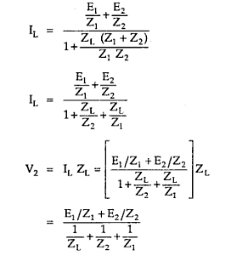
If impedances Z₁ and Z₂ are small in comparison with load impedance Z_{L} then product Z₁ Z₂ may be neglected so we get,
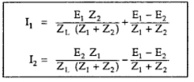
But we know that
(E₁ - E₂) / (Z₁ + Z₂) = I_{c}
Key Point: This circulating current I_{c} adds to I₁ but subtracts from I₂. Hence transformer 1 gets overloaded. The transformers will not share the load according to their ratings. The I_{C} leads to increase the copper loss.

The phasor diagram is shown in the Fig. 2.12
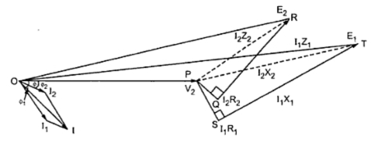
Fig. 2.12
The two transformers will operate at different power factor Φ₁ and Φ₂ are the power factor angles of these two transformers whereas Φ is the combined p.f. angle.
Here E_{A} and E_{B} have the same phase but there may be some phase difference between the two due to some difference of internal connection as for the connection in parallel of a Star/Star and a Star/Delta 3 phase transformers.
Key Point: While solving the problems on parallel operation of transformers it is convenient to work with numerical values of impedances instead of percentage values.

